**Chapter 16**

16.1 a The slope coefficient tells us that for additional inch of father’s height the son’s height increases on average by .516. The y-intercept is meaningless.

b On average the son will be shorter than his father.

c On average the son will be taller than his father.

16.2 a



b     

23 9.6 529 92.16 220.8

46 11.3 2,116 127.69 519.8

60 12.8 3,600 163.84 768.0

54 9.8 2,916 96.04 529.2

28 8.9 784 79.21 249.2

33 12.5 1,089 156.25 412.5

25 12.0 625 144.00 300.0

31 11.4 961 129.96 353.4

36 12.6 1,296 158.76 453.6

88 13.7 7,744 187.69 1205.6

90 14.4 8,100 207.36 1296.0

99 15.9 9,801 252.81 1,574.1

Total 613 144.9 39,561 1,795.77 7,882.2

= 613 ****= 144.9 ****= 39,561 ****= 7,882.2

= 

= 

 = 





= 12.08 – (0.0582)(51.08) = 9.107

The sample regression line is

 = 9.107 + 0.0582x

The slope tells us that for each additional thousand Euros of advertising sales increase on average by 0.0582 million. The y-intercept has no practical meaning.

16.3 a     

8.5 115 72.25 13,225 977.5

7.8 111 60.84 12,321 865.8

7.6 185 57.76 34,225 1,406.0

7.5 201 56.25 40,401 1,507.5

8.0 206 64.00 42,436 1,648.0

8.4 167 70.56 27,889 1,402.8

8.8 155 77.44 24,025 1,364.0

8.9 117 79.21 13,689 1,041.3

8.5 133 72.25 17,689 1,130.5

8.0 150 64.00 22,500 1,200.0

Total 82.0 1,540 674.56 248,400 12,543.4

= 82.0 ****= 1,540 ****= 674.56 ****= 12,543.4

= 

= 

 = 





= 154.0 – (–39.17)(8.20) = 475.2

The sample regression line is

 = 475.2 – 39.17x

b The slope coefficient tells us that for each additional 1 percentage point increase in mortgage rates, the number of housing starts decreases on average by 39.17. The y-intercept has no meaning.

16.4 a



b     

42 18 1,764 324 756

34 6 1,156 36 204

25 0 625 0 0

35 –1 1,225 1 –35

37 13 1,369 169 481

38 14 1,444 196 532

31 7 961 49 217

33 7 1,089 49 231

19 –9 361 81 –171

29 8 841 64 232

38 8 1,444 64 304

28 5 784 25 140

29 3 841 9 87

36 14 1,296 196 504

18 –7 324 49 –126

Total 472 86 15,524 1,312 3,356

= 472 ****= 86 ****= 15,524 ****= 3,356

= 

= 

 = 





= 5.73 – (0.9675)(31.47) = –24.72

The sample regression line is

 = –24.72 + 0.9675x

The slope coefficient indicates that for each additional hour of television weight increases on average by 0.9675 pounds. The y-intercept is the point at which the regression line hits the y–axis; it has no practical meaning.

16.5 a     

80 20,533 6,400 421,604,089 1,642,640

68 1,439 4,624 2,070,721 97,852

78 13,829 6,084 191,241,241 1,078,662

79 21,286 6,241 453,093,796 1,681,594

87 30,985 7,569 960,070,225 2,695,695

74 17,187 5,476 295,392,969 1,271,838

86 30,240 7,396 914,457,600 2,600,640

92 37,596 8,464 413,459,100 3,458,832

77 9,610 5,929 92,352,100 739,970

84 28,742 7,056 826,102,564 2,414,328

Total 805 211,447 65,239 5,569,844,521 17,682,051

= 805 ****= 211,447 ****= 65,239 ****= 17,682,051

= 

= 

 = 





= 21,145 – (1,513)(80.5) = –100,652

The sample regression line is

 = –100,652 + 1,513x

b For each additional one-degree increase in temperature the number of beers sold increases on average by 1,513. The y-intercept is the point at which the regression line hits the y–axis; it has no practical meaning.

16.6 a



b = = 0.2675, = 13.80 – 0.2675(38.00) = 3.635

Regression line: = 3.635 + 0.2675x (Excel: = 3.636 + 0.2675x)

c = 0.2675; for each additional second of commercial, the memory test score increases on average by 0.2675. = 3.64 is the y-intercept.

16.7 a =  = 210.4 – 1.465(13.68) =190.4.

Regression line: = 190.4 + 1.465x (Excel: = 190.4 + 1.465x)

b For each additional floor prices increase on average by €1.465 thousand (€1,465).   
The y-intercept has no practical meaning.

16.8 =  = 11.55 – 0.0899(45.49) =7.460.

Regression line: =7.460 + .0899x (Excel: = 7.462 + .0900x)

The slope coefficient tells us that for each additional year of age time increases on average by 0.0899 minutes. The y-intercept has no meaning.

16.9 a = = 26.28 – (–0.11697)(37.29) = 30.64.

Regression line: = 30.64 – 0.1169x (Excel: = 30.63 – 0.1169x)

b The slope coefficient indicates that for each additional year of age, the employment period decreases on average by 0.1169. = 30.63 is the y-intercept.

16.10 a= = 14.43 – 0.1898(37.64) = 7.286.

Regression line: = 7.286 + 0.1898x (Excel: = 7.287 + 0.1897x)

b For each additional cigarette the number of days absent from work increases on average by 0.1898. The y-intercept has no meaning.

16.11 =  = 49.22 – 5.347(4.885) = 23.10.

Regression line: = 23.10 + 5.347x (Excel: = 23.11 + 5.347x)

For each addition mile a house is away from its nearest fire station the percentage damage increases on average by 5.347.

16.12 a=  = 6,465 – 44.97(53.93) = 4040.

Regression line: = 4040 + 44.97x (Excel: = 4040 + 44.97x)

b For each additional thousand square feet the price increases on average by €44.97 thousand.

16.13= = 27.73 – (–0.00138)(1199) = 29.39.

Regression line:  = 29.39–0.00138x (Excel: 29.39–0.00138x)

For each additional hour the price decreases on average by 0.00138 thousand euros or €1.38.

16.14 = = 762.6 –64.05(4.75) = 458.4.

Regression line:= 458.4 + 64.05x (Excel: = 458.9 + 64.00x)

For each additional occupant the electrical use increases on average by 64.05.

16.15 = = 270.3 –1.959(59.42) = 153.9.

Regression line:= 153.9 + 1.959x (Excel: = 153.9 + 1.958x)

For each additional €1,000 of income the weekly food budget increases on average by €1.96.

16.16 a = = 17.20 – (–0.3039)(11.33) = 20.64.

Regression line: = 20.64 – 0.3039x (Excel: = 20.64 – 0.3038x)

b The slope indicates that for each additional one percentage point increase in the vacancy rate rents on average decrease by €0.3039.

16.17 a = , = 59.59 – 0.604(68.95) =17.94.

Regression line: = 17.94 + 0.604x (Excel: = 17.93 + 0.604x)

b For each additional inch of height income increases on average by €0.604 thousand or €604.

16.18 == 93.89 – 0.0514(79.47) = 89.81.

Regression line:  = 89.81 + 0.0514x (Excel:  = 89.81 + 0.0514x)

For each additional mark on the test the number of non-defective products increases on average by 0.0514.

16.19 For each commercial length, the memory test scores are normally distributed with constant variance and a mean that is a linear function of the commercial lengths.

16.20 For each number of years of education incomes are normally distributed with constant variance and a mean that is a linear function of the number of years of education.

16.21 For each number of hours prices are normally distributed with constant variance and a mean that is a linear function of the number of hour.

16.22 b     

1 1 1 1 1

3 8 9 64 24

4 15 16 225 60

6 33 36 1089 198

9 75 81 5625 675

8 70 64 4900 560

10 95 100 9025 950

Total 41 297 307 20,929 2,468

= 41 ****= 297 ****= 307 **=** 20,929 ****= 2,468

= 

= 

= 

 = 

= 

= (Excel: = 8.85)





Rejection region: or 

= 

= (Excel: t = 10.07, p–value = 0). There is enough evidence to infer a linear relationship.



There does appear to be a linear relationship.

16.23 a



There does appear to be a linear relationship.

b     

3 25 9 625 75

5 110 25 12100 550

2 9 4 81 18

6 250 36 62500 1500

1 3 1 9 3

4 71 16 5041 284

Total 21 468 91 80,356 2,430

= 21 ****= 468 ****= 91 = 80,356 ****= 2,430

= 

= 

= 

 = 

= 

= (Excel: = 44.75)





Rejection region: or 

= 

= (Excel: t = 4.23, p–value = 0.0134). There is enough evidence to infer a linear relationship.

16.24 a = 

= 

= (Excel: = 1.347)

b 



Rejection region: or 

= 

= (Excel: t = 3.93, p–value = 0.0028). There is enough evidence to infer a linear relationship between advertising and sales.

c  LCL = 0.0252, UCL = 0.0912

d =(Excel:  = 0.6066). 60.67% of the variation in sales is explained by the variation in advertising.

e There is evidence of a linear relationship. For each additional euro of advertising sales increase, on average by 0.0582.

16.25 = 

=(Excel:  = 0.2948).

= 

= (Excel: = 31.48)





Rejection region: or 

= 

= (Excel: t = 1.83, p–value = 0.1048. There is not enough evidence to infer a linear relationship between interest rates and housing starts.

16.26 = 

= 

= 





Rejection region: or 

= 

= (Excel: t = 6.55, p–value = 0.)   
There is enough evidence to conclude that there is a linear relationship between hours of television viewing and how overweight the child is.

16.27 = 

= 

= 





Rejection region: or 

= 168.6

= (Excel: t = 8.98, p–value = 0.)   
There is evidence of a linear relationship between temperature and the number of beers sold.

16.28 a = 

= (Excel: = 5.888). Relative to the values of the dependent variable the standard error of estimate appears to be large indicating a weak linear relationship.

b = (Excel:  = 0.2893).

c 



Rejection region: or 

= 

= (Excel: t = 4.86, p–value = 0).

There is enough evidence to infer a linear relationship between memory test scores and length of commercial.

d  LCL = 0.1756, UCL = 0.3594

16.29 = 

= (Excel: = 19.41). Relative to the values of the dependent variable the standard error of estimate appears to be large indicating a weak linear relationship.

=(Excel:  = 0.2566).





Rejection region: or 

= 

= (Excel: t = 4.07, p–value = 0.0002).   
There is evidence of a linear relationship. The relationship however, is weak.

16.30 = 

= 





Rejection region: or 

= 

= (Excel: t =2.18, p–value = 0.0305.)   
There is evidence of a linear relationship between age and time to complete census.

16.31 = 

= (Excel: = 1.813). Relative to the values of the dependent variable the standard error of estimate appears to be large indicating a weak linear relationship.

=(Excel:  = 0.1884). There is a weak linear relationship between age and number of weeks of employment.

16.32 = 

= 





Rejection region: or 

= 

= (Excel: t =7.49, p–value = 0.) There is evidence of a positive linear relationship between cigarettes smoked and the number of sick days.

16.33 = 

= (Excel: = 11.11).

a 



Rejection region: or 

= 

= (Excel: t =9.12, p–value = 0.)   
There is evidence of a linear relationship between distance and fire damage.

b  LCL = 4.18, UCL = 6.51

c =(Excel:  = 0.5004).   
There is a moderately strong linear relationship between distance and fire damage.

16.34 = 

a= (Excel: = 3,287). There is a weak linear relationship.

b 



Rejection region: or 

= 

= (Excel: t = 2.24, p–value = 0.0309.)   
There is enough evidence of a linear relationship.

c =(Excel:  = 0.1168) 11.67% of the variation in percent damage is explained by the variation in distance to the fire station.

16.35 = 

= (Excel: = 1.889).





Rejection region: 

= 

= (Excel: t = –1.367, p–value = 0.1769/2 = 0.0885.)   
There is not enough evidence to infer that as hours of engine use increase the price decreases.

16.36 = 

=  (Excel: = 192.5).

= (Excel:  = 0.3496)   
35.00% of the variation in the electricity use is explained by the variation in the number of occupants.





Rejection region: or 

= 

= (Excel: t =10.32, p–value = 0.)   
There is enough evidence of a linear relationship.

16.37 a =(Excel:  = 0.2459)   
24.61% of the variation in food budgets is explained by the variation in household income.

b = 

= (Excel: = 36.94).





Rejection region: or 

= 

= (Excel: t = 6.95, p–value = 0.)   
There is evidence of a linear relationship between food budget and household income.

16.38 = 

=  (Excel: = 2.873).





Rejection region: or 

= 

= (Excel: t = –3.39, p–value = 0.0021.)   
There is sufficient evidence to conclude that office rents and vacancy rates are linearly related.

16.39 = 

=  (Excel: = 8.28).





Rejection region: 

= 

= (Excel: t = 3.63, p–value = 0.00034/2 = 0.00017)   
There is enough evidence to conclude that height and income are positively linearly related.

16.40 a=(Excel:  = 0.0331)   
3.31% of the variation in percentage of defectives is explained by the variation in aptitude test scores.

b = 

=  (Excel: = 1.127).





Rejection region: or 

= 

= (Excel: t = 1.21, p–value = 0.2319)   
There is not enough evidence to conclude that aptitude test scores and percentage of defectives are linearly related.

16.41 



Rejection region: 



(Excel: t = –1.367, p–value = 0.0885)   
There is not enough evidence to infer a negative linear relationship.

16.42 



Rejection region: or 



(Excel: t = 4.86, p–value = 0)   
This result is identical to the one produced in Exercise 16.6.

16.43 



Rejection region: or 



(Excel: t = 6.95, p–value = 0.)   
There is evidence of a linear relationship between food budget and household income.

16.44 



Rejection region: 



(Excel: t = 7.49, p–value = 0.)   
There is evidence of a positive linear relationship between cigarettes smoked and the number of sick days.

16.45

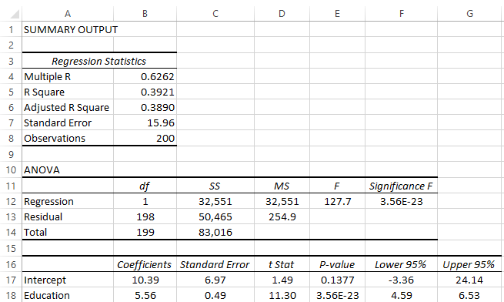

a H0:β1 = 0

H1:β1 ≠ 0

t = 11.30, p-value = 0.   
There is enough evidence to conclude that there is a linear relationship between the two variables.

b LCL = 4.59, UCL = 6.53

16.46

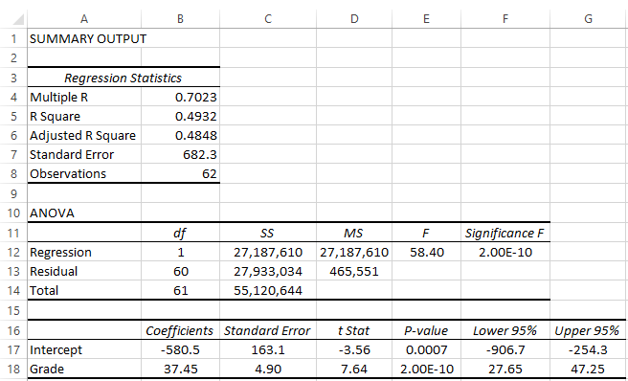

a H0:β1 = 0

H1:β1 ≠ 0

t = 7.64, p-value = 0.   
There is enough evidence to infer that there is a linear relationship between grade and price.

b R2 = 0.4932; 49.32% of the variation in price is explained by the variation in grade.

16.47

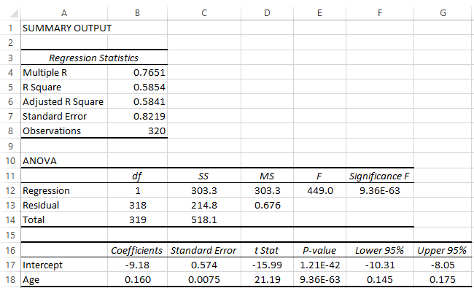

a H0:β1 = 0

H1:β1 ≠ 0

t = 21.19, p-value = 0. There is enough evidence to infer that there is a linear relationship between age and number of days watching national news on television.

b R2 = 0.5854; 58.54% of the variation in number of days is explained by the variation in age.

16.48

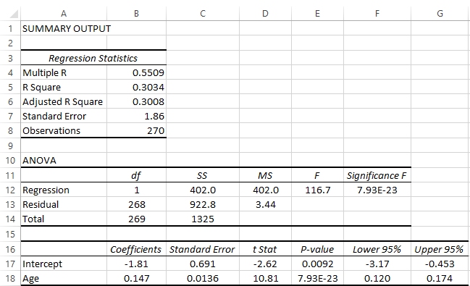

H0:β1 = 0

H1:β1 ≠ 0

t = 10.81, p-value = 0.   
There is enough evidence to infer that age and intention to vote are linearly related.

16.49

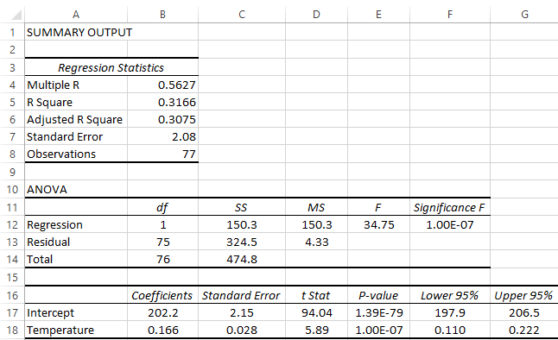

a H0:β1 = 0

H1:β1 ≠ 0

t = 5.89, p-value = 0. There is not enough evidence to infer that there is a positive linear relationship between temperature and distance.

b R2 = 0.3166; 31.66% of the variation in distance is explained by the variation in temperature.

16.50 H0:β1 = 0

H1:β1 ≠ 0

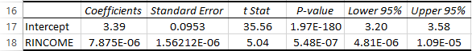

t = 5.04, p-value = 0. There is enough evidence to infer that there is a linear relationship between income and position on the question: should the government reduce income differences between rich and poor.

16.51

LCL = 554.3, UCL = 837.1

16.52 H0:β1 = 0

H1:β1 < 0



t = -8.58, p-value = 0.   
There is enough evidence to conclude that more educated people watch less television.

16.53 H0:β1 = 0

H1:β1 > 0

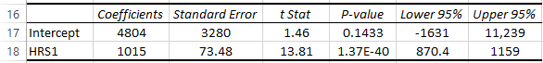

a t = 13.81, p-value = 0.   
There is enough evidence to infer that more hours of work leads to higher income.

b LCL = 870.4, UCL = 1159.

16.54 H0:β1 = 0

H1:β1 ≠ 0



t = -0.239, p-value = 0.8115.   
There is not enough evidence to infer a linear relationship between age and hours of work per week.

16.55 H0:β1 = 0

H1:β1 > 0



t = 5.67, p-value = 0.   
There is enough evidence to infer a positive linear relationship between age and hours of watching television per day.

16.56 H0:β1 = 0

H1:β1 > 0

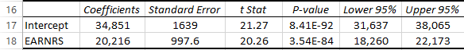

t = 20.26, p-value = 0.   
There is enough evidence of a positive linear relationship between total family income and the number of earners in the family.

LCL = 18,260 UCL = 22,173

16.57 H0:β1 = 0

H1:β1 > 0



t = 3.45, p-value = 0.00058/2 = 0.00029.   
There is enough evidence to conclude that more educated people are more likely to support government action to reduce income differences across the country differences.

16.58 H0:β1 = 0

H1:β1 > 0



t = 27.08, p-value = 0.   
There is sufficient evidence to conclude that a married person’s years of education are positively linearly related to his or her spouse’s level of education.

16.59 H0:β1 = 0

H1:β1 > 0



t = 1.17, p-value = 0.2439.   
There is not enough evidence to infer that as people become richer they tend to have more children.

16.60 H0:β1 = 0

H1:β1 > 0

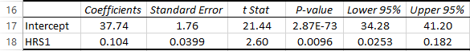

t = 2.60, p-value = 0.0096.   
There is enough evidence to conclude that if one spouse works longer hours so does the spouse.

16.61 H0:β1 = 0

H1:β1 > 0



t = 17.99, p-value = 0.   
There is sufficient evidence to infer a positive linear relationship between years of education and the age when one has his or her first child.

16.62 H0:β1 = 0

H1:β1 < 0



t = -10.04, p-value = 0.   
There is enough evidence to conclude that more educated people have fewer children.

16.63 H0:β1 = 0

H1:β1 > 0

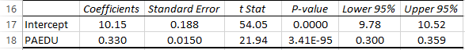

t = 21.94, p-value = 0. There is enough evidence to infer that the amount of education one completes is positively linearly related to his or her father.

16.64 H0:β1 = 0

H1:β1 > 0



t = 23.41, p-value = 0. There is enough evidence to conclude that there is a positive linear relationship between the years of education and the years of education of one’s mother.

16.65 H0:β1 = 0

H1:β1 > 0

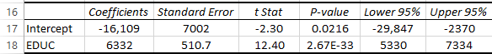

t = 12.40, p-value = 0.   
There is enough evidence to conclude that more education leads to higher incomes.

b LCL = 5330, UCL = 7334

16.66 H0:β1 = 0

H1:β1 > 0



t= 10.83, p-value = 0.   
There is enough evidence to conclude that more education increases financial assets.

b LCL = 6181, UCL = 8917

c



The coefficient of determination is 0.0889, which means that 8.89% of the variation in financial assets is explained by the variation in education.

16.67 H0:β1 = 0

H1:β1 > 0

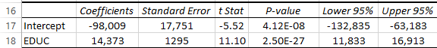

t = 11.10, p-value = 0.   
There is enough evidence to conclude that education and debt are positively linearly related.

b LCL = 11,833, UCL = 16,913

c



The coefficient of determination is 0.0931, which means that 9.31% of the variation in debt is explained by the variation in education.

16.68 H0:β1 = 0

H1:β1 < 0



t = -12.22, p-value = 0. There is evidence of a negative linear relationship.

16.69 H0:β1 = 0

H1:β1 > 0



a t = 6.67, p-value = 0. There is enough evidence to infer a positive linear relationship.

b LCL = 815.6, UCL = 1495.

16.70 H0:β1 = 0

H1:β1 < 0



t = -9.12, p-value = 0. There is enough evidence to infer that age and amount spent on food away from home are negatively related.

16.71 H0:β1 = 0

H1:β1 < 0



t = -9.08, p-value = 0. There is enough evidence of a negative linear relationship.

16.72 H0:β1 = 0

H1:β1 > 0

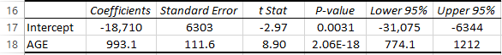

t = 8.90, p-value = 0.   
There is enough evidence to conclude that as one grows older one increases unrealized capital gains.

16.73



a H0:β1 = 0

H1:β1 > 0

t = 18.01, p-value = 0. There is enough evidence of a positive linear relationship.

b LCL = 1324, UCL = 1648

16.74

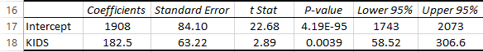

a H0:β1 = 0

H1:β1 > 0

t = 2.89, p-value = 0.0039/2 = 0.0040.   
There is enough evidence of a positive linear relationship.

b LCL = 58.52, UCL = 306.6.

16.75 The prediction interval provides a prediction for a value of y. The confidence interval estimator of the expected value of y is an estimator of the population mean for a given x.

16.76 Yes, because 

16.77 

Prediction interval: (where 

=

Lower prediction limit = 11.10, Upper prediction limit = 16.42 (Excel: 11.10, 16.41)

16.78 

Confidence interval estimate: (where 



LCL = 149.94, UCL = 252.06 (Excel: 149.75, 252.25)

16.79 

a Prediction interval: (where 

=

Lower prediction limit =2.086, Upper prediction limit = 16.200 (Excel: 2.095, 16.209)

b Confidence interval estimate: 



LCL = 7.166, UCL = 11.120 (Excel: 7.174, 11.130)

16.80 

Prediction interval: (where 

=

Lower prediction limit = 5,739, Upper prediction limit = 19,907 (Excel: 5,740, 19,902)

16.81  3.636 + 0.2675(30) = 11.61

a Prediction interval: (where 

=

Lower prediction limit = -0.3 (changed to 0), Upper prediction limit = 23.52 (Excel: -0.26, 23.58)

b Confidence interval estimate: 



LCL = 9.85, UCL = 13.37 (Excel: 9.90, 13.42)

16.82 190.4 + 1.465(20) = 219.7

a Prediction interval: (where 

=

Lower prediction limit = 180.1, Upper prediction limit = 259.4 (Excel: 180.0, 259.4)

b 190.4 + 1.465(15) = 212.4

Confidence interval estimate:  (where 



LCL = 204.9, UCL = 219.9 (Excel: 204.9, 219.8)

16.83 7.46 + 0.0899(40) = 11.06

Confidence interval estimate:  (where 



LCL = 10.26, UCL = 11.86 (Excel: 10.26, 11.86)

16.84 30.64 – 0.1169(22) = 28.07

Prediction interval: (where 

=

Lower prediction limit = 24.34, Upper prediction limit = 31.80 (Excel: 24.33, 31.79)

16.85 7.286 + 0.1898(40) = 14.88

Prediction interval: (where 

=

Lower prediction limit = 7.03, Upper prediction limit = 22.73 (Excel: 6.98, 22.77)

16.86  23.10 + 5.347(8) = 65.88

a Prediction interval: (where 

=

Lower prediction limit = 43.37, Upper prediction limit = 88.39 (Excel: 43.37, 88.39)

b  23.10 + 5.347(5) = 49.84

Confidence interval estimate: 



LCL = 47.44, UCL = 52.24 (Excel: 47.44, 52.24)

16.87  4,040 + 44.97(60) = 6,738

Confidence interval estimate:  (where 



LCL = 5,659, UCL = 7,817 (Excel: LCL = 5,657, UCL = 7,818)

16.88 29.39 – 0.00138(400) = 28.84

Prediction interval: (where 

=

Lower prediction limit = 23.34, Upper prediction limit = 34.34 (Excel: 23.33, 34.35)

16.89 458.4 + 64.05(4) = 714.6

Confidence interval estimate:  (where 



LCL = 691.0, UCL = 738.2 (Excel: 691.2, 738.7)

16.90 153.9 + 1.959(60) = 271.4

Prediction interval: (where 

=

Lower prediction limit = 210.0, Upper prediction limit = 332.8 (Excel: 210.0, 332.7)

16.91 20.64 – 0.3039(8) = 18.21

Prediction interval: (where 

=

Lower prediction limit = 12.20, Upper prediction limit = 24.22 (Excel: 12.19, 24.22)

16.92 a17.94 + 0.604(74) = 62.64

Confidence interval: (where 

=

Lower confidence limit = 60.70, Upper confidence limit = 64.58 (Excel: 60.70, 64.59)

b 17.94 + .604(68) = 59.01

Prediction interval: (where 

= 

Lower prediction limit = 42.75, Upper prediction limit = 75.27 (Excel: 42.67, 75.36)

16.93  89.81 + 0.0514(80) = 93.92

Confidence interval estimate:  where 



LCL = 93.58, UCL = 94.26 (Excel: 93.57, 94.26)

16.94

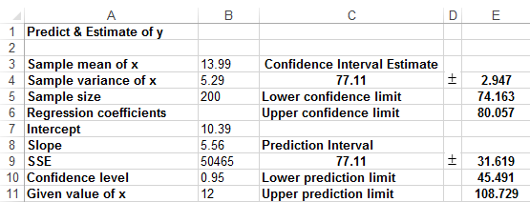

LCL = 74.163, UCL = 80.057.

16.95

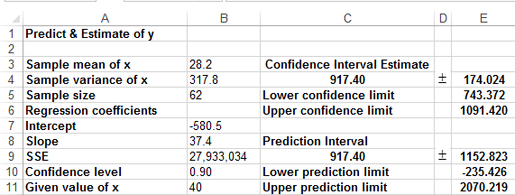

Lower prediction interval = -235.426, upper predication interval = 2070.219

16.96

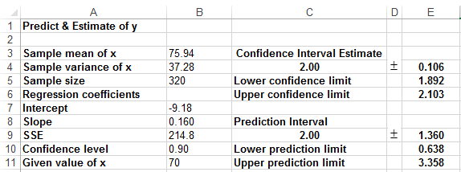

LCL = 1.892, UCL = 2.103

16.97

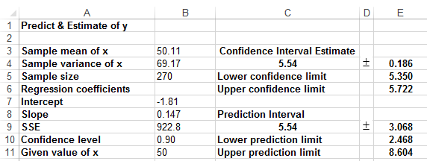

Lower prediction interval = 2.468, upper predication interval = 8.604

16.98

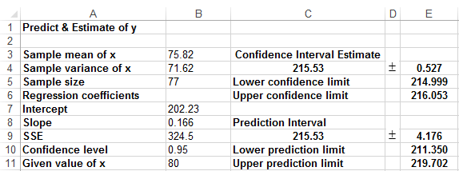

Lower prediction interval = 211.350, upper predication interval = 219.702.

16.99 In all cases the linear relationship is far too weak to produce accurate predictions.

16.100





Lower prediction interval = 7.679, upper predication interval = 19.723.

LCL = 13.578, UCL = 13.823

16.101







Lower prediction interval = -1.680, upper predication interval = 8.262.

LCL = 3.150, UCL = 3.432.

16.102







Lower prediction interval = -28,401, upper predication interval = 119,175.

LCL = 43,322, UCL = 47,387.

16.103







Lower prediction interval = 13.64, upper predication interval = 69.99

LCL = 40.69, UCL = 42.93

16.104







Lower prediction interval = -1.722, upper predication interval = 8.346.

LCL = 3.144, UCL = 3.480.

16.105







Lower prediction interval = 26,400, upper predication interval = 205,033.

LCL = 110,196, UCL = 121,237.

16.106







Lower prediction interval = -33,469, upper predication interval = 123,084.

LCL = 42,645, UCL = 46,970.

16.107







Lower prediction interval = -1.021, upper predication interval = 5.224.

LCL = 2.019, UCL = 2.184.

16.108







Lower prediction interval = 9.72, upper predication interval = 20.47.

LCL = 14.94, UCL = 15.25.

16.109





Lower prediction interval = 11.39, upper predication interval = 22.13.

LCL = 16.50, UCL = 17.03.

16.110 The relationship between the dependent and independent variables is too weak to provide accurate predictions.

16.111 a     

–5 15 25 225 –75

–2 9 4 81 –18

0 7 0 49 0

3 6 9 36 18

4 4 16 16 16

7 1 49 1 7

Total 7 42 103 408 –52

= 7 ****= 42 ****= 103 ****= –52

= 

= 

 = 





= 7.000 – (–1.065)(1.167) = 8.253

The sample regression line is:

 = 8.253 – 1.065x

b, c, & d = 

= 

=  (Excel: = 1.268)

    

–5 15 13.58 1.42 1.118

–2 9 10.38 –1.38 –1.087

0 7 8.253 –1.253 –0.987

3 6 5.058 0.942 0.742

4 4 3.993 0.007 0.0055

7 1 0.798 0.202 0.159

There are no outliers.

16.112     23 9.6 10.45 –0.85

46 11.3 11.78 –0.48

60 12.8 12.60 0.20

54 9.8 12.25 –2.45

28 8.9 10.74 –1.84

33 12.5 11.03 1.47

25 12.0 10.56 1.44

31 11.4 10.91 0.49

36 12.6 11.20 1.40

88 13.7 14.23 –0.53

90 14.4 14.35 0.06

99 15.9 14.87 1.03

16.113    = 475.2 – 39.17x 

8.5 115 142.3 –27.3

7.8 111 169.7 –58.7

7.6 185 177.5 7.5

7.5 201 181.4 19.6

8.0 206 161.8 44.2

8.4 167 146.2 20.8

8.8 155 130.5 24.5

8.9 117 126.6 –9.6

8.5 133 142.3 –9.3

8.0 150 161.8 –11.8

16.114 a & b    = – 24.72 + 0.9675x 

42 18 15.92 2.09

34 6 8.18 –2.18

25 0 –0.53 0.53

35 –1 9.14 –10.14

37 13 11.08 1.92

38 14 12.05 1.96

31 7 5.27 1.73

33 7 7.21 –0.21

19 –9 –6.34 –2.66

29 8 3.34 4.66

38 8 12.05 –4.05

28 5 2.37 2.63

29 3 3.34 –0.34

36 14 10.11 3.89

18 –7 –7.31 0.31

c



16.115    = –100,652 + 1,513x 

80 20,533 20,388 145

68 1,439 2,232 –793

78 13,829 17,362 –3,533

79 21,286 18,875 2,411

87 30,985 30,979 6

74 17,187 11,310 5,877

86 30,240 29,466 774

92 37,596 38,544 –948

77 9,610 15,849 –6,239

84 28,742 26,440 2,302

*The histograms drawn below are of the standardized residuals, which make it easier to see whether the shape is extremely nonnormal. It also makes it easier to identify outliers. The shape of the resulting histogram is identical to the histogram of the residuals using the equivalent class limits.*

16.116 b & c



Because the histogram is approximately bell shaped the errors appear to be normally distributed. There are two residuals whose absolute value exceeds 2.0.

d



There is no indication of heteroscedasticity.

16.117 a



The histogram is not bell shaped. However, residuals do not appear to be extremely nonnormal.

c



There is no clear indication of heteroscedasticity.

16.118

The error variable appears to be normally distributed.

The variance of the error variable is constant.

16.119 b & c



The error variable appears to be normally distributed. There are three observations whose standardized residuals are greater than 2.0.

d



The variance of the error variable is constant.

16.120



The error variable appears to be normally distributed.



The variance of the error variable is constant.

16.121 b



The errors appear to be normally distributed.

c There are no outliers.

d



The variance of the error variable appears to decrease somewhat as the predicted values increase. However, the effect is not large enough to be a problem.

16.122



The error variable appears to be normally distributed.



There is no clear sign of heteroscedasticity.

16.123



The error variable appears to be normally distributed.



The variance of the error variable is constant.

16.124



The error variable appears to be normal.



The variance of the error variable is constant.

16.125



The error variable appears to be normal.



The variance of the error variable is constant.

16.126



The error variable appears to be normal.



The variance of the error variable is constant.

16.127



The error variable appears to be normal.



The variance of the error variable is constant.

16.128



The error variable appears to be normal.



The variance of the error variable is constant.

16.129 a == 384.81 – 21.33(4.12) = 296.93

Regression line:  = 296.93 + 21.33x (Excel:  = 296.92 + 21.36x)

b On average each additional ad generates 21.33 customers.

c = 

= (Excel: = 132.96).





Rejection region: 

= 

= (Excel: t = 1.50, p–value = 0.1479/2 = 0.0740.)   
There is not enough evidence to conclude that the larger the number of ads the larger the number of customers.

d =(Excel:  = 0.0852).   
There is a weak linear relationship between the number of ads and the number of customers.

e The linear relationship is too weak for the model to produce predictions.

16.130 a == 395.21 – 2.47(113.35) = 115.24.

Regression line:  = 115.24 + 2.47x (Excel:  = 114.85 + 2.47x)

b = 2.47; for each additional month of age, repair costs increase on average by €2.47.

= 114.85 is the y-intercept.

c =(Excel:  = 0.5659)   
56.59% of the variation in repair costs is explained by the variation in ages.

d = 

=  (Excel: = 43.32).





Rejection region: or 

= 

= (Excel: t = 4.84, p–value = 0.0001.   
There is enough evidence to infer that repair costs and age are linearly related.

e 

Prediction interval: (where 

=

Lower prediction limit = 318.1, upper prediction limit = 505.2 (Excel: 318.1, 505.2)

16.131 a == 318.60 – 0.123(300) = 281.7.

Regression line:  = 281.7 + 0.123x (Excel:  = 281.8 + 0.123x)

The slope is 0.123, which tells us that for each additional unit of fertilizer, corn yield increases on average by 0.123. The y-intercept is 281.7, which has no real meaning.

b = 

=  (Excel: = 71.38).





Rejection region: or 

= 

= (Excel: t = 1.33, p–value = 0.1938.   
There is not enough evidence to infer a linear relationship between amount of fertilizer and corn yield.

c =( Excel:  = 0.0595)   
5.95% of the variation in corn yield is explained by the variation in amount of fertilizer.

d The model is too poor to be used to predict.

16.132 



Rejection region: or

(Excel: 0.5540)

(Excel: t = 13.77, p–value = 0).   
There is enough evidence of a positive linear relationship. The theory appears to be valid.

16.133 



Rejection region: or 

(Excel: 0.3984)

(Excel: t = 3.01, p–value = 0.0042).   
There is enough evidence of a linear relationship. The theory appears to be valid.

16.134 





t = 6.63, p-value = 0.   
There is enough evidence to conclude that there is a positive linear relationship between the value of the fund and the price of gold.

16.135 





t = 1.67, p-value = 0.0522.   
There is not enough evidence to infer that when the times between movies increase so do sales.

16.136 The intervals between values must be constant, which is arguable.

16.137 H0:β1 = 0

H1:β1 > 0



t = 5.34, p-value = 0.   
There is enough evidence to infer that older people are more likely to be conservative.

16.138 H0:β1 = 0

H1:β1 > 0



t = 2.30, p-value = 0.0218/2 = .0109.   
There is enough evidence to infer that as income increases people are more likely to be conservative.

16.139 H0:β1 = 0

H1:β1 < 0



t = -5.05, p-value = 0.   
There is enough evidence to infer that as education increases people are more likely to be liberal.

16.140 H0:β1 = 0

H1:β1 > 0

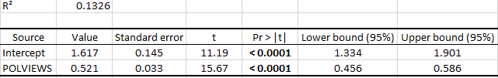

t = 15.67, p-value = 0.

16.141 H0:β1 = 0

H1:β1 > 0

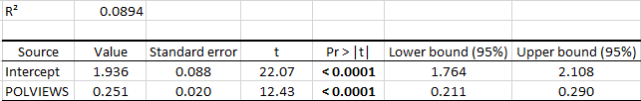

t = 12.43, p-value = 0.

16.142 H0:β1 = 0

H1:β1 > 0

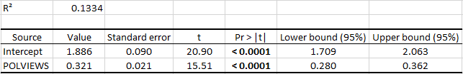

t = 15.51, p-value = 0.

16.143 H0:β1 = 0

H1:β1 > 0

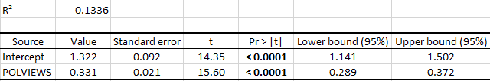

t = 15.60, p-value = 0.

16.144 In general liberals want government to act and conservatives want no government action. However, the coefficients of determination indicate weak relationships.

Case 16.1 a



The regression equation is = 16.23 + 0.693x. This equation was used to predict museum attendance when it was closed (observations 33 to 179). The sum of the predictions is 785,009.

b



The regression equation is = 459.5 + 0.970x.   
This equation was used to predict museum attendance when it was closed (observations 33 to 179). The sum of the predictions is 1,162,994.

c The predicted lost revenue should be based on the regression using the first 32 weeks. Multiply 785,009 by the price of tickets and subtract fixed costs to produce the amount the insurance company should pay the museum.

Case 16.2

Regression using the best 6 OACs:



t = 10.63, p–value = 0.   
There is evidence of a linear relationship between the average of the best 6 OACs and university GPA. = 0.2385, = 0.8295

Regression using the best 4 OACs plus English and calculus:



t = 13.97, p–value = 0; there is evidence of a linear relationship between the average of the best 4 OACs plus English and calculus and university GPA. = 0.3509, = 0.7658.

The second model fits better (higher coefficient of determination and lower standard error of estimate) and as such is likely to be a better predictor of university GPA.